H.B. MCDANIEL FOUNDATION

SCHOLARSHIP PROGRAM APPLICATION
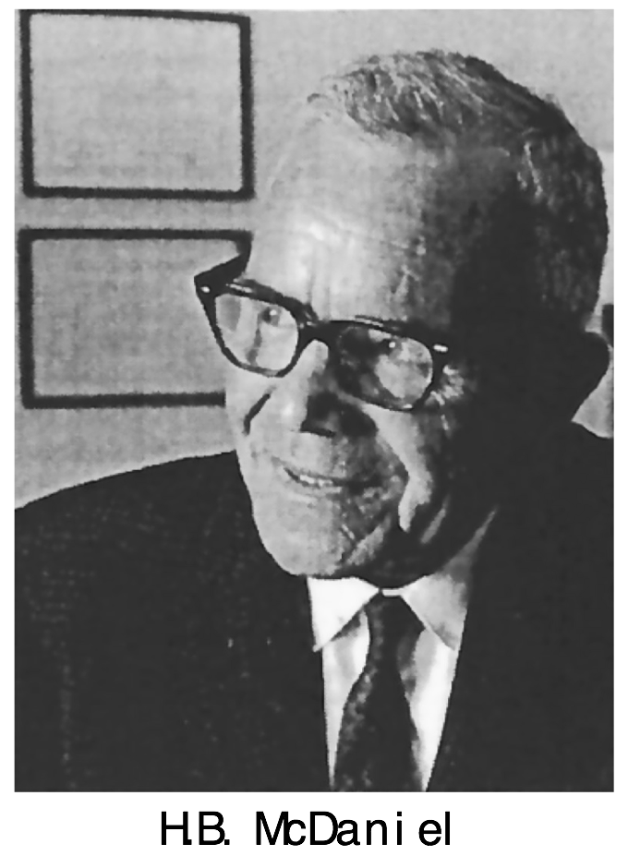
Henry Bonner (H.B.) McDaniel, the father of school counseling and guidance in California, was a Professor of Education at Stanford University. During that time, he pioneered postgraduate training for California counseling and guidance personnel. These scholarships honor the legacy of educational excellence, leadership, and service of H.B. McDaniel, for whom the foundation is named. This year, the McDaniel Foundation is pleased to offer three unique scholarships:

- DALE C. BURKLUND MEMORIAL RESEARCH SCHOLARSHIP
The H.B. McDaniel Foundation honors the legacy of Dr. Dale C. Burklund through a research scholarship in his memory. A school counselor, dean, teacher, and leader in innovative research and assessment projects at local, state, and national levels, Dr. Burklund developed a unique career counseling program which is still used in many schools today. Dr. Burklund was mentored by H.B. McDaniel, completing his doctoral graduation requirements at Stanford University in just two years. A founding member and first chairperson of the McDaniel Foundation, he served as the group’s secretary for 40 years. This scholarship recognizes the promise of graduate students in school counseling through research and/or counseling interventions.

- JAMES WILLIAM ALLEN MEMORIAL SERVICE SCHOLARSHIP
The Allen family has designated this annual service scholarship as a memorial to a school counselor and faithful supporter of the H.B. McDaniel Foundation. In the spirit of giving and service, James William Allen—a school counselor in the Fremont Unified School District and husband of Dr. Jackie M. Allen—dedicated himself to work with all students and families to help young people attain their academic goals and reach their potential. This scholarship celebrates the outstanding service that school counselors provide for their students, families, and schools.

- JOHN D. KRUMBOLTZ CAREER DEVELOPMENT SCHOLARSHIP
The H.B. McDaniel Foundation is thrilled to celebrate the extensive academic, research, and publication record of Dr. John D. Krumboltz through a career development scholarship for aspiring school counselors. A professor of education and psychology at Stanford University since 1961 and recent Professor Emeritus, Dr. Krumboltz’s contributions to the fields of counseling psychology and career counseling are significant, innumerable, and lasting. Having been a colleague and friend of H.B. McDaniel, Dr. Krumboltz has served on the McDaniel Foundation Board for more than 30 years. This scholarship aims to honor the planned and unplanned learning experiences that characterize the career trajectory of a school counselor.

APPLICANT INSTRUCTIONS
- Decide which scholarship you would like to apply for.
- Compile the supplemental materials (e.g., transcript, letter of recommendation, statements, etc.) that you will need in order to apply.
- Complete the Scholarship Application online OR complete the traditional application that follows.
  - ONLINE APPLICANTS: You will upload your supplemental materials directly into your online application. Once you click submit, you have completed the application process.
  - TRADITIONAL APPLICANTS: Please insert all supplemental materials into your application file. Save your completed application as ONE .doc, .docx, or PDF file. Include your last name in the file name for your application. Email your completed application file to:
Aubrey Uresti, Scholarship Committee Chair
hbmcdanielscholarshipcommittee@gmail.com

Note:
Each applicant may apply for one scholarship. Therefore, applicants are encouraged to consider which of these scholarships best represents their interests.

SCHOLARSHIP APPLICATION

Please indicate which scholarship you would like to be considered for:

I am applying for the ____________________________________________________________ Scholarship.

Applicant Information
Name:
Current address:
City: | State: | ZIP Code:
Phone: | Email:

Education Information
Institution Name:
Institution Address:
City: | State: | ZIP Code:
Program of Study:
Begin Date: | Expected Graduation: | Grade-Point Average (GPA)/Scale:
Please insert scanned image(s) of your master’s program academic record in the “Transcript” section below. The image(s) must be easy to read and should include a transcript legend. A copy of an official transcript or unofficial transcript is acceptable.

Professional Information
Professional Counseling Organization:
Member Since:
Please insert your current resume or curriculum vitae in the “Resume” section below.

Recommender Information
Name:
Institution Name: |  | Position:
Relationship to Applicant:
Phone: | Email:
Please insert a letter of recommendation from a professor/supervisor in the “Recommendation” section below. The letter must be written on professional/business letterhead and should include the recommender’s signature.

Statement Information
Henry Bonner McDaniel, the father of school counseling and guidance in California, was a Professor of Education at Stanford University. During that time, he pioneered postgraduate training for California counseling and guidance personnel. These scholarships honor the legacy of educational excellence, leadership, and service of H.B. McDaniel, for whom the foundation is named. You may apply for:
- a research scholarship based on a school counseling project you are working on or plan to carry out, OR
- a service scholarship based on service to a school or community that advances the profession of school counseling, OR
- a career development scholarship based on your career goals in school counseling.
Please consider the ideals of H.B. McDaniel as you prepare the following essay statements:
- Personal Statement: In 300 words or less, discuss how your personal background informs your decision to pursue a master’s degree in school counseling. Please include any educational, familial, cultural, economic, or social experiences, challenges, or opportunities relevant to your academic journey. Tell your personal story with examples of your achievements and leadership, individual personality and character, and an indication of financial need.
- School Counseling Issues Statement: In 500 words or less, discuss the crucial issues for school counseling in California, your future career goals, and the contributions that you believe you can make to the field of school counseling.
- If you are applying for the research scholarship, please describe the research project and/or counseling intervention that you plan to carry out as a graduate student or future school counselor.
- If you are applying for the service scholarship, please describe your service with underserved populations.
- If you are applying for the career development scholarship, consider the following: Dr. John Krumboltz writes that, "Luck is no accident," and that chance encounters play an important role in our career development. Please describe how your future career has been shaped by both planned and unplanned learning experiences with people, institutions, and/or events.
Please insert your statements in the corresponding sections below.

Application Certification
I certify that the information and supplemental materials provided on this application are accurate. I also understand that, if I am awarded the scholarship, I must be present at the April 5, 2019 banquet at Stanford.
Signature of applicant: | Date:

Transcript

Resume

Recommendation

Personal Statement

School Counseling Issues Statement

